1. Use the installed MySQL in the Given Folder to create the database BidvestBank:

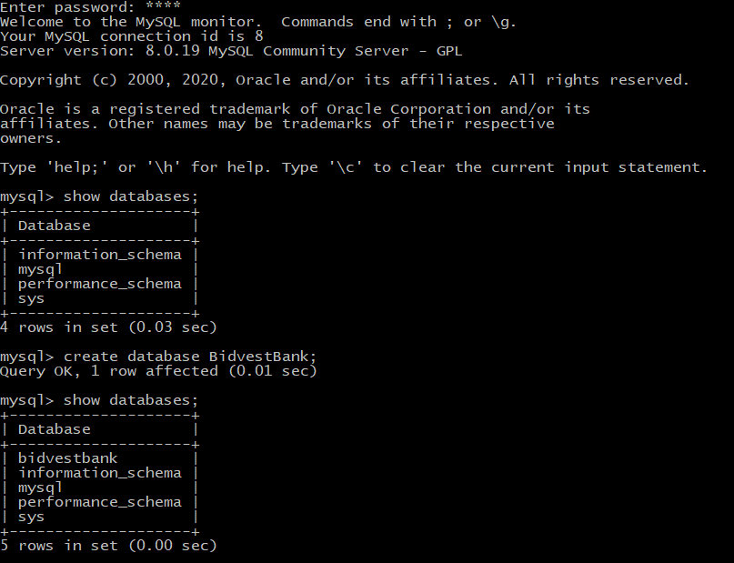

2. For all the above tables identify which of the attributes can be used as primary keys and assign primary keys to those tables.

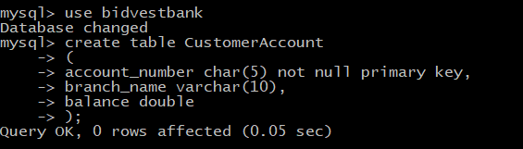

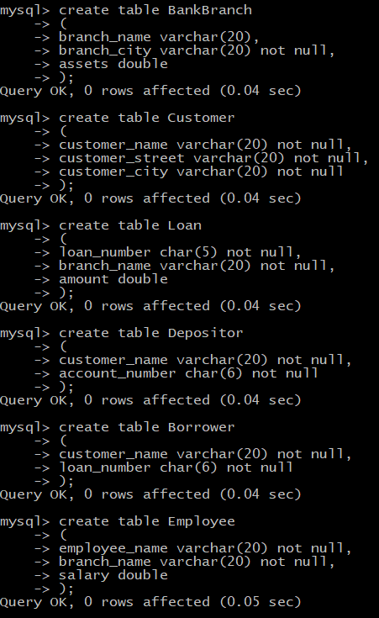

3. Populate all the tables:

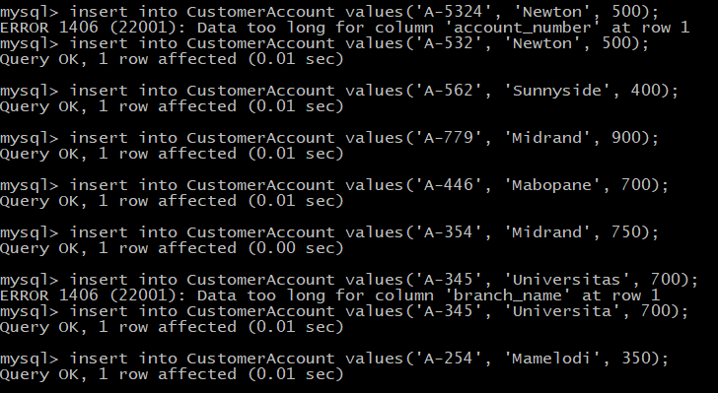

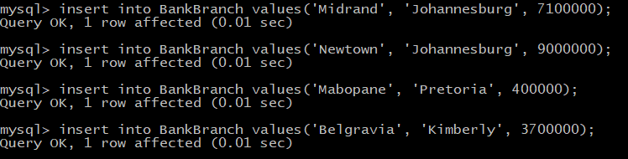

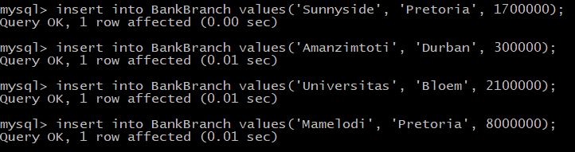

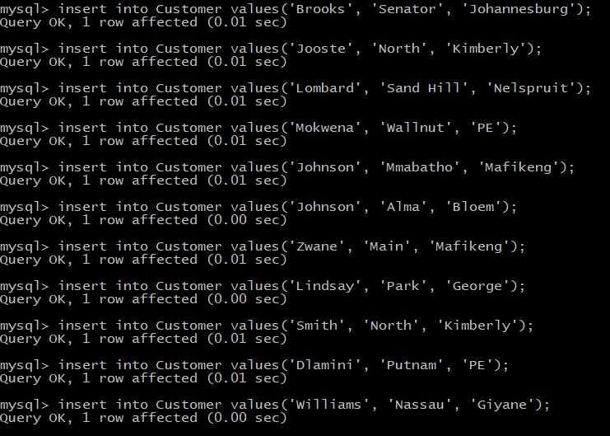

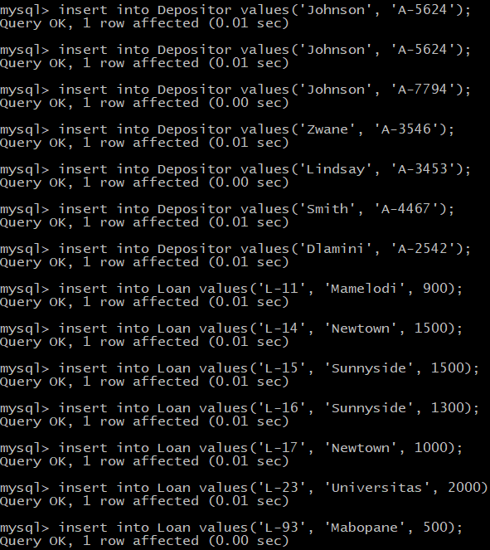

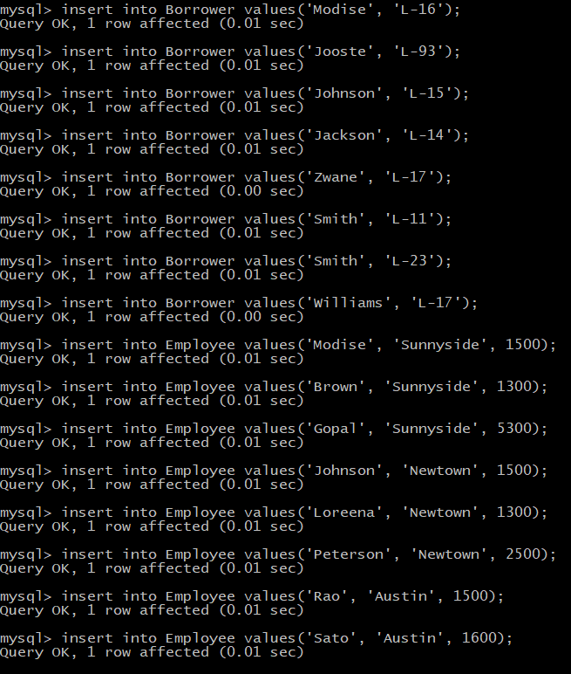

4. Perform the following queries on the BidvestBank database and show the screenshot of each query.

1. Find all customer accounts whose balance is smaller than R700.
2. Find all name of customers whose city is in Johannesburg.
3. Find all employees whose salary is greater than R1500 and working branch is not Newtown.
4. Calculate the average salary of all employees and show the average salary as “avg_salary”
5. Display the bank with the largest number of Assets.

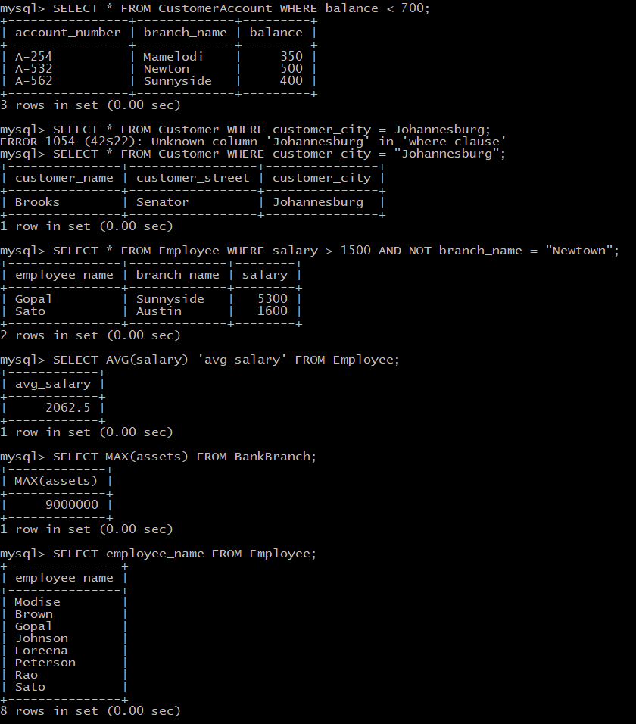

5. Provide the SQL code which can utilize BidvestBank database to provide the following:

1. Display the names of all employees who work in Sunnyside branch.
2. Display the borrower table.
3. Find the account number for all accounts where the balance is greater than R900.
4. Find the account number and balance for all accounts from Newtown where the balance is greater than R600.
5. Display the branch name and assets from all branches.

